Friday ,24th March

On friday , we got up at 6:30am in the morning, we went for breakfast and we had:
-toast,cereals,fruit shoot,hot chocolate...
Before we left we prepared our suitcases and we left at 7.15am to the car park at
Bexleyheath.
We went from Bexleyheath to London by coach . We arrived and parked next to the Thames and
we walked to the London Dungeon. We arrived and we did the tour of London
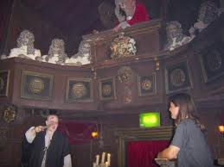
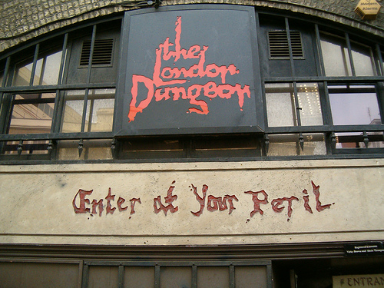
Dungeon through horror terrifying rooms of death when you got scared and they jumped out at
you and sprayed fake blood (=water).

We were standing next to a middle-ages tribunal while Maeva was sittting in front of everyone on a chair and the person was saying to cut her arm or hands so they turned the lights off and through fake blood at us in the croud we were soaked.

Our tour was finished and we walked all the way to the london eye where we went to have lunch, in the street there was lots of shows,shrek...After eating we walked 10mn to leake street where we looked at the grafts on the walls(one of them where brand new. Our day is nearly finished, so to finish we went to Covent Garden and Jubilee Market were all the pupils went shopping we bought: jumpers,key rings.....
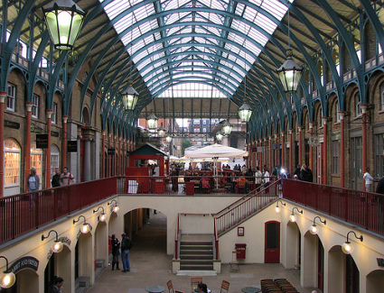

Finally but not least we walked back to the bus who was parked nes to the Thames, we rode in the bus all the way to the train station . We parked in the train and had some dinner in it, after 35 minutes we arrived and drove of of the train ans continued howre route to Merdrignac. We arrived round 7.00 o'clock in merdignac at Per Jakez Helias to go home to our homes.



