Second day
Tuesday 20th March:

1.We got up at 6:30 pm; we ate at 7:00 pm. We had a shower at 7:15 pm and we went to the carpark at 8:00 pm.

2. We arrived in London at 9:00 pm
We visited the Natural History Museum; it is a big monument.

In the museum there are a tyrannosaur Rex and reconstitution of seisms .
- 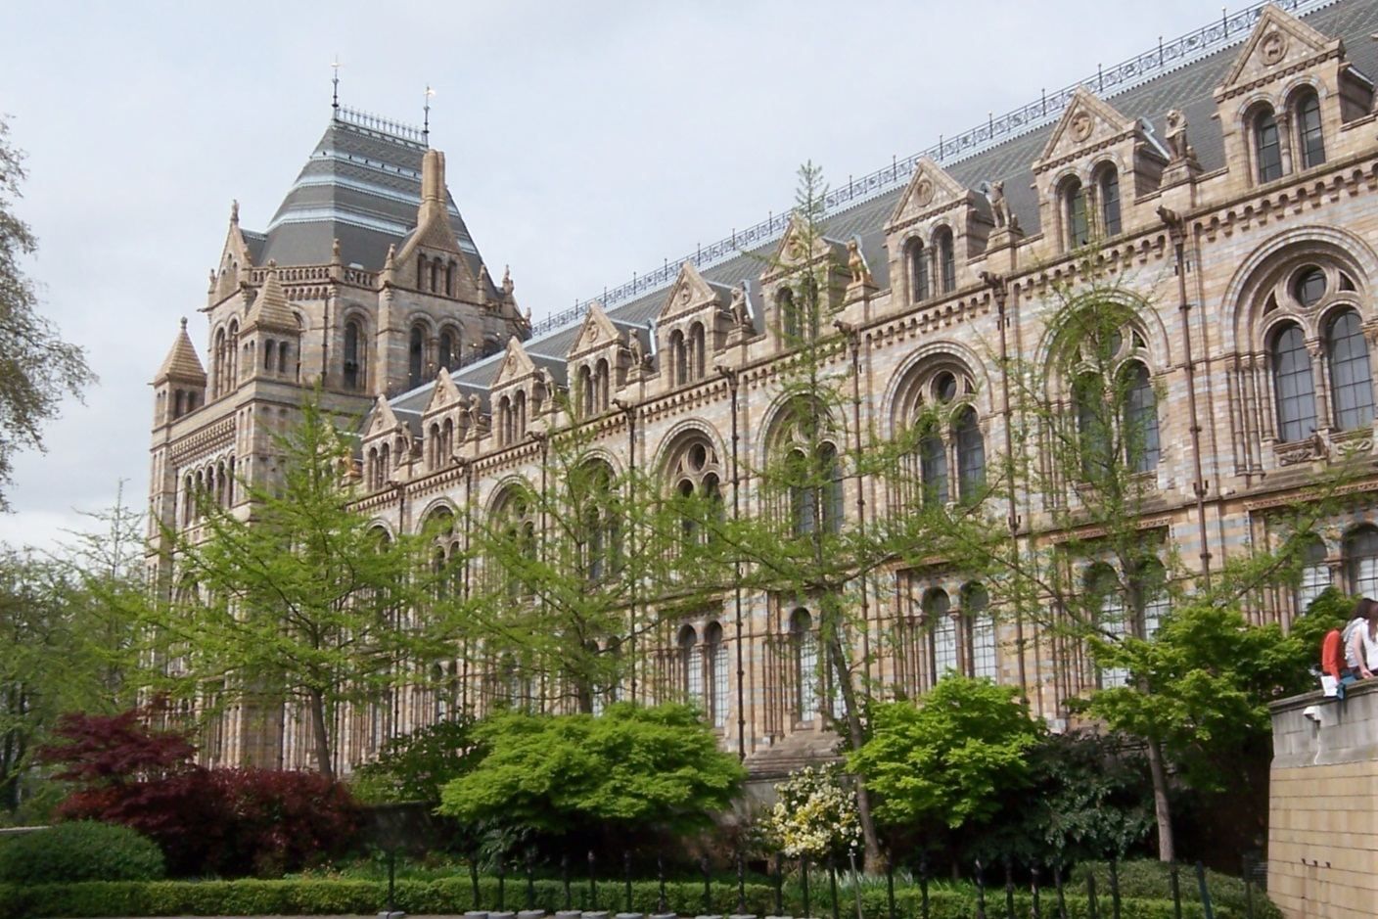
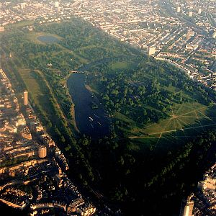

we arrived in Hyde park at 12pm we ate sandwiches and chips and apple,water,cereal bar

we walked along the Thames we arrived in the Tate museum at 14:30pm ,
in the museum we saw paintings , works of illusion ,
The museum was a former power station.
The Tate is now a Modern Art Gallery,
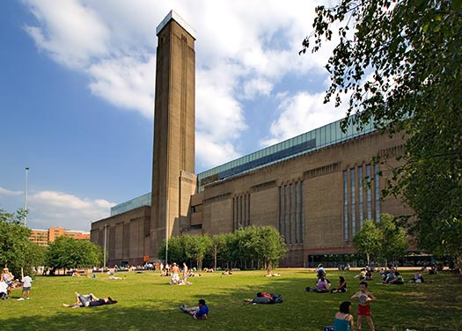

We went back to the coach at 5:30pm and we arrived in the carpark at 7:00pm

In the family we ate spaghetti Bolognese and yogurt we went to bed
at 21:00pm.

